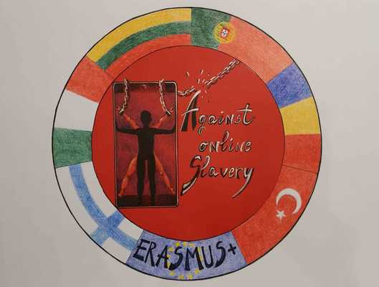
LESSON PLAN | AGAINST ONLINE SLAVERY (2019-1-FI01-KA229-060725)

Country + School: | Romania, Scoala Gimnaziala Nicolae Romanescu
Teacher(-s)
Subject / Course:
Topic: | ”Fake News”
Age group: | 13-17 | Lesson Duration: | 50 minutes

Lesson Objectives which the students acquire:
Lesson aims:
a. General aims:
- To engage students in interaction and meaningful communication
- To get students to express their opinion/point of view on controversial topics
- To become more socially responsible
b. Specific aims: at the end of the lesson, students will be better able to:
- Define propaganda
- Identify fake news
- Determine the credibility of a source
- Understand the mechanism and the reasons behind sharing fake news online
Evaluation: continuous (constant observation, error-correction); final (oral feedback, homework).
Assumptions: Students already possess a set of skills that enables them to express themselves fluently in English.
Anticipated problems: Some students may have difficulty in expressing their point of view.

Summary of Tasks / Actions:
PROCEDURE
No. 1
Stage of the lesson: Warm up
Teacher’s activity The teacher greets students,
checks attendance and homework.
Students’ activity Students correct their homework
Didactic strategies: conversation
Skills
Types of interaction T-Ss
Duration of activity 5 minutes

No. 2
Stage of the lesson Lead-in
Teacher’s activity The teacher chooses a piece of news which is proven to be fake, shows it to the students and asks them if the information is true,stating their points of view.The teacher introduces the
elements that contribute to the making of some news which they should pay attention to when they
determine the credibility of certain information online.
T asks and helps S identify:
-The context of the article;
- What they know about the author and the newspaper/ magazine/ site;
-What kind of article is it (news, comment, opinion etc.); is all the information introduced, are all the
points of view there?
-Is there a certain form of propaganda or misinformation?
-Does the information appear in other credible sources?
- After allowing them a few minutes to note their ideas, several pairs read their answers to
the whole class.
Students’ activity Students do the task. They state their points of view to the whole class. Students work in pairs in order to identify the elements with the help of materials and questions from the teacher. A member of the pair reads the idea to the whole class.
Didactic strategies Conversation, deduction
Skills Reading Speaking
Types of interaction T-Ss, S-S
Duration of activity 10 minutes

No. 3
Stage of the lesson Defining fake news
Teacher’s activity
The teacher tells students that they are going to try to find a definition for fake news. The teacher reads the definition provided by the European Parliamentary Research Service. The teacher explains that there are also other fake online contents, such as: fake publicity, fake charity campaigns or conspiracy theories.
The teacher explains that fake news are not a modern invention, but a centuries-old custom. The teacher offers the students handout 1 in which The Great Moon Hoax (1835) is illustrated. She asks the students to search for some online information about this topic.
Students’ activity Students try to find the definition,taking into account the data above. They put down the definition: ”Fake news – deliberately fabricated stories posing as journalism with the aim of manipulating readers .”In groups, the students read the handouts and search for the required information.
Didactic strategies Conversation, explanation
Skills Reading, speaking
Types of interaction T-Ss; Ss-T
Duration of activity 15 minutes

No. 4
Stage of the lesson How fake news roll out
Teacher’s activity
The teacher provides the students with handout 2, asking them to put the stages of rolling out fake
news into the right order.The teacher reads the NASA official statement regarding fake news about the asteroid.
Students’ activity In pairs, the students check the quoted sources and put ticks.Eventually, they specify which the primary source was (NASA). The conclusion is that the three sites had quoted one another and
fake news rolled out.
Didactic strategies Conversation, explanation
Skills Reading, speaking
Types of interaction Ss-Ss, T-Ss, Ss-T
Duration of activity10 minutes

No. 5
Stage of the lesson Discussing the context and mechanism

Teacher’s activity The teacher introduces another piece of fake news. She asks the students:
-Why is fake news and information spread?
-Who can take profit of it?
-Sometimes, the news is published on social media on purpose, to emphasize the fact that it is fake.
Does this situation apply here?
Students’ activity Students try to answer the questions they find on handout 3 and discuss with the teacher about the motivation behind fake news or conspiracy theories, about the mechanism by which every click
generates traffic, publicity and profit.
Didactic strategies Conversation
Skills Reading, speaking
Types of interaction Ss-Ss, T-Ss, Ss-T
Duration of activity 5 minutes

No. 6
Stage of the lesson Feedback and homework
Teacher’s activity Teacher offers students oral feedback for their performance during class and grades students. She announces homework:”Your homework is to find a piece of online fake news (each of you)
and to analyse it using handout 3.”
Students’ activity Students note their homework
Didactic strategies Conversation
Skills
Types of interaction T-Ss
Duration of activity. 5 minutes

Materials / Equipment:
Teaching aids: board, notebooks, laptop and projector, handouts
Skills: reading, speaking, writing

References/ theories/ teaching methods used:
Teaching techniques/methods:
a. Skills: reading, speaking, writing
b. Didactic strategies: conversation, explanation
c. Class organisation: group work, pair work, individual work, whole class;
Types of interaction: S-S, T-SS
2
d. Teacher’s role: coordinator, advisor, monitor, resource, help

Sources:
https://propaganda.mediaeducationlab.com/ro
https://drive.google.com/file/d/1gM1ABE513kQa2t_VEa17wX7oGV3oXGS4/view
https://www.europarl.europa.eu/at-your-service/en/stay-informed/research-and-analysis
3

Evaluation of the objectives acquired:
Evaluation: continuous (constant observation, error-correction); final (oral feedback, homework).

